

September 2013

Overview and Scrutiny Committee

Accessible Transport
Report from Scrutiny Review Group

Members of the review group

Councillor Sue Anderson (chair)

Councillor Marilyn Ashton

Councillor Jerry Miles

Councillor John Nickolay

Councillor Stephen Wright

Tony Wood – Harrow Public Transport Users Assn

TABLE OF CONTENTS
Page
1. Chair’s foreword 2
2. Introduction and scope 4
3. Policy background 5
Responsibilities for the provision of public transport 5
Funding situation 5
4. Findings and recommendations 7
The significance of accessible public transport 7
Pavements and footpaths 8
Buses and bus stops 11
Trains, underground (tube) and overground 13
Stations 16
Travel information 18
Consultation with residents 19
5. Conclusion 20
6. Recommendations 21
7. Acknowledgements 23

1. CHAIR’S FOREWORD
1.1 Accessibility to transport is an issue raised time and time again by residents of Harrow – both by residents with disabilities and without. The concerns expressed by residents have been the main drivers for this review. During the review, we have sought to identify the extent and significance of barriers to accessible transport in Harrow and with that knowledge, suggest improvements for the Council and Transport for London (TfL) to undertake.
1.2 I would like to thank the residents who attended our seminar as well as the residents who took the time to complete our consultation. I would also like to extend a thank you to the two residents who gave up their time to travel through the borough with members of the review group - they were instrumental to the conclusions of this review. The support from many community groups in informing their members about the review is much appreciated also.
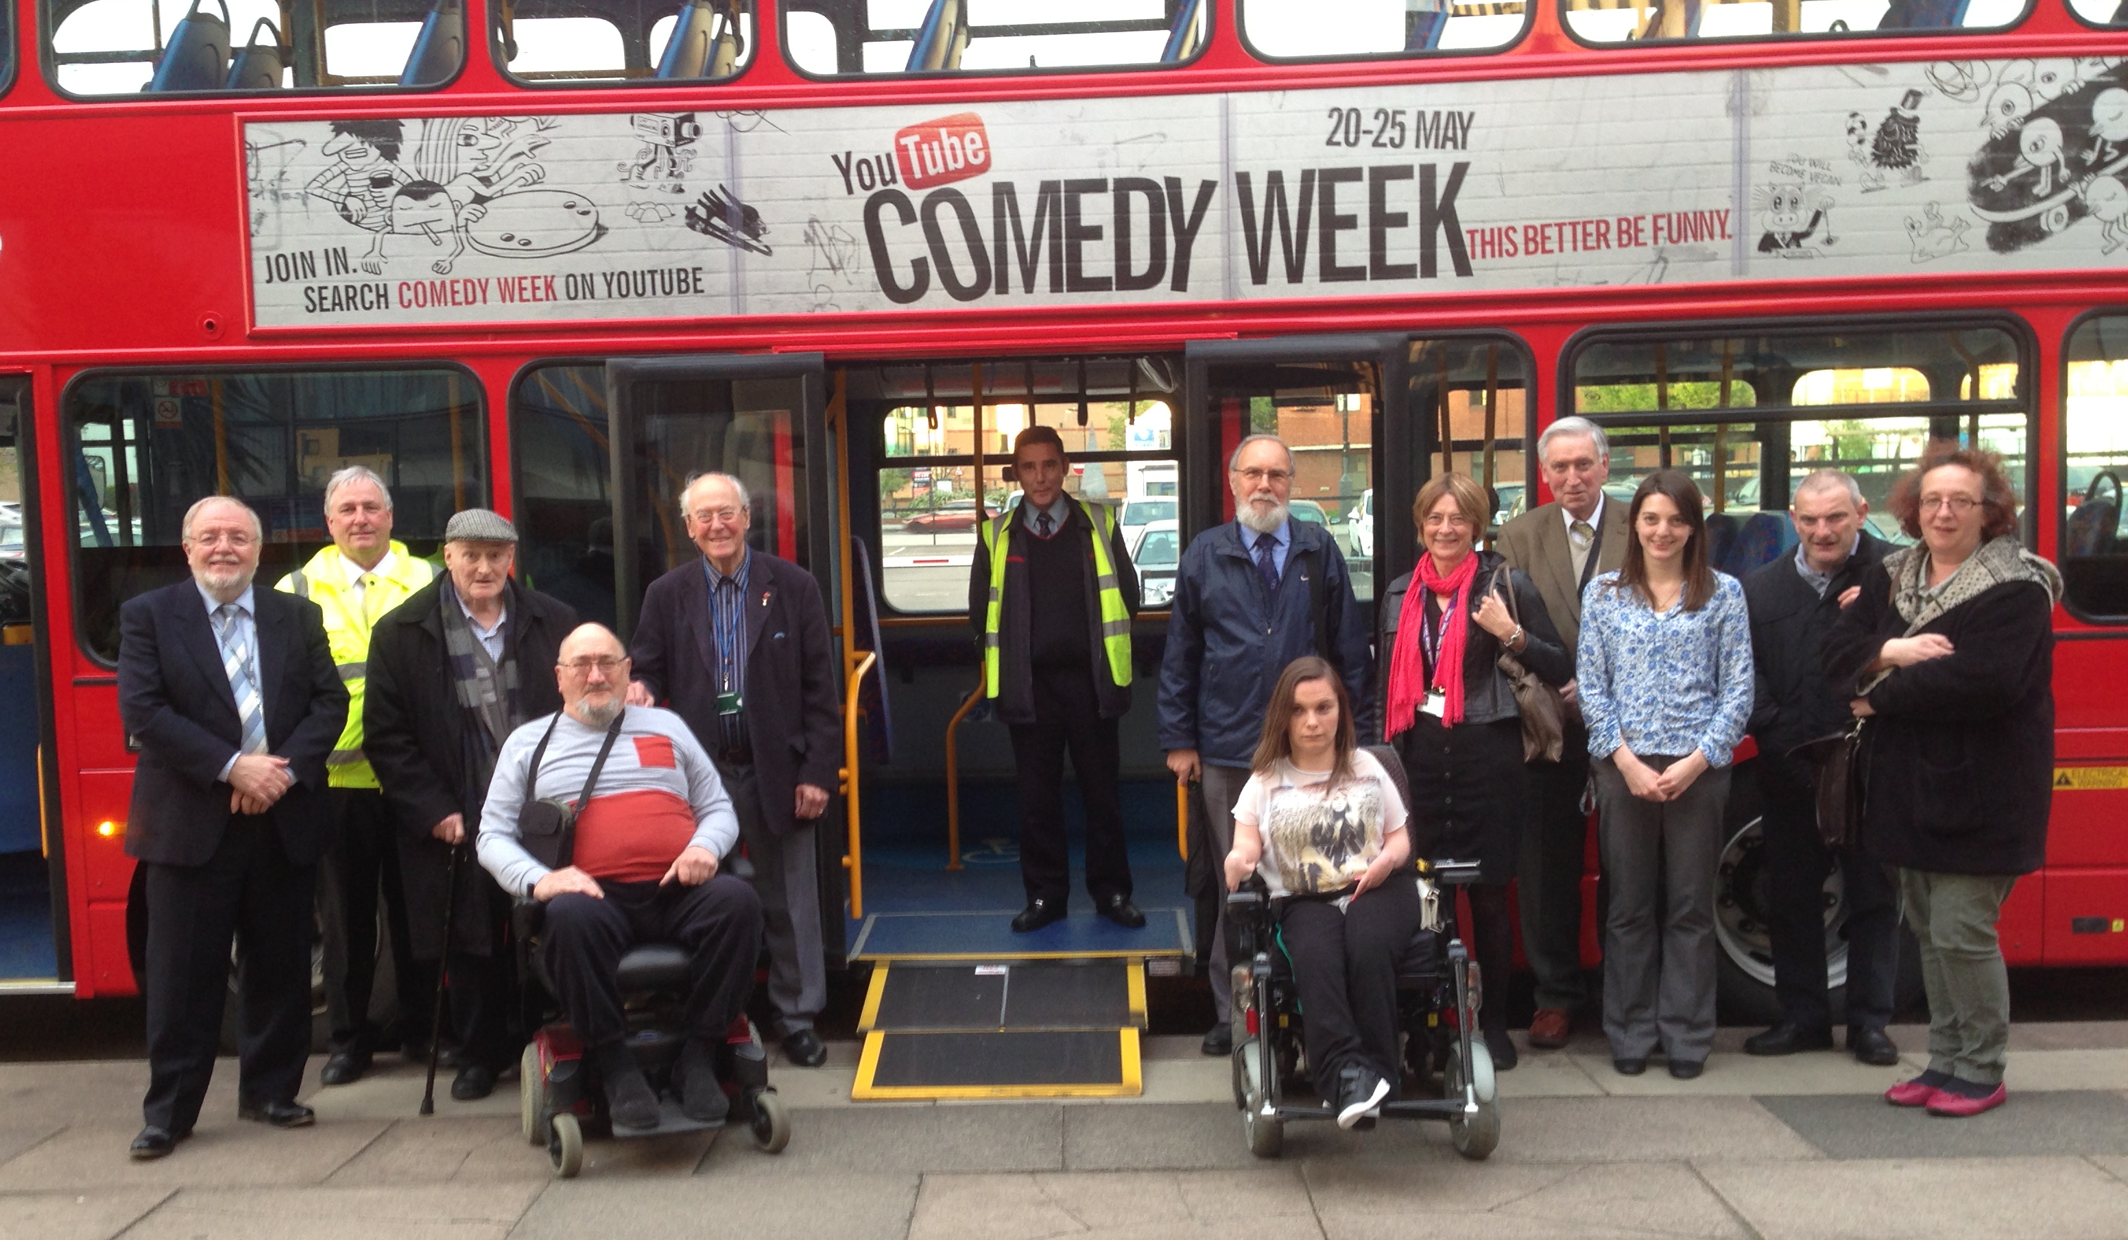
1.3 The local bus company Metroline has cooperated with the review by attending our seminar and contributing valuable information. The double-decker bus they provided enabled those attending the seminar to get familiar with the bus in a quiet environment and with the assistance of staff. I would like to thank Metroline for their cooperation and support.
1.4 I also want to thank the representatives from London TravelWatch, Harrow Community Transport, London Sovereign, Metroline, London Underground Limited and Transport for London who attended our round table discussion. They provided us with valuable information, were open to discuss the difficulties identified during the review and joined us in thinking about potential solutions.
1.5 The officers of Harrow Council have been very supportive of our work and I would like to thank all of them for contributing their knowledge and time - sometimes at short notice: Peter Barron, Matthew Patterson, Stephen Kelly, Hanif Islam, David Eaglesham, Phil Greenwood, Ann Fine, Paul Newman, Mohammed Ilyas, Paul Najsarek and Fern Silverio. I also want to extend a special thanks to the scrutiny officer supporting this review, Simone van Elk, for all her hard work.
1.6 A final thanks to the co-optee to this review, Tony Wood, for contributing his time as well as his extensive knowledge and expertise which have proved to be invaluable.
1.7 The policy around provision of public transport cuts across many different organisations and as such it can be challenging for the Council to impact on outcomes directly. We have made a number of recommendations to Cabinet which we hope will strengthen the Council’s work on accessible transport and influence the work of its partners.
On behalf of the members of the review group, I commend this report.

Councillor Sue Anderson
Chair of the Accessible Transport review
2. INTRODUCTION AND SCOPE
2.1 Residents of Harrow have indicated repeatedly that the accessibility of transport in the borough is of concern to them. The review has included a seminar with residents, journeys through the borough with two residents with different disabilities and a consultation to gain an understanding of the positive and negative aspects of the accessibility of public transport in the Borough.
2.2 Truly accessible transport enables people to travel from door-to-door. As well as looking at transport provided by Transport for London (TfL) and train companies, the review has also focused on the Council’s provision of public highways (roads, highways and pavements). While public highways aren’t strictly modes of transport, they are a necessary means to reach any transport. The interaction between the Council and transport providers has been a constant factor. The members of the review group have therefore met with Council officers to gain information as well as organise a roundtable discussion with both officers and providers of transport to discuss issues raised by residents and the possibilities for improvements.
2.3 The budgets available to improve the accessibility of transport are generally limited. This not only prohibits large scale projects from taking place but also means that smaller works need to be carefully prioritised. In that context, this review has sought to make a number of recommendations that are efficient and (relatively) cost-effective as well as identify priorities for future works that are of a larger scale and more costly.
2.4 The aims of the review have therefore been to:
- identify the issues arising from using public transport on the life opportunities of people with disabilities or with restricted mobility, as well as other residents in Harrow
- identify priority developments in Harrow to enhance the life experience for people with disabilities or restricted mobility – several priorities could be identified but cost may determine the priority
- support the Council’s lobbying position with Transport for London
- support the development of the town centre
2.5 The review group has focused on the accessibility of public transport. Concessionary travel such as Dial-a-Ride, Taxicard scheme and Community Transport are not open to the general public and as such these services including their eligibility criteria have not been a part of this review.
3. POLICY BACKGROUND
Responsibilities for the provision of public transport
3.1 TfL provides the overall majority of public transport in London: tube, overground, buses, Docklands Light Railway (DLR), riverboats and tram services. Bus routes are generally provided by bus companies commissioned by TfL, while TfL manages the underground and overground services either directly or via a limited company.
3.2 The train services in London are provided by a number of different companies, some sharing train routes. Stations that allow interchanges between different modes of transport are generally managed by only one of the organisations using the station.
3.3 Harrow Council is responsible for the provision and maintenance of a large proportion of the streets in the borough. This includes the provision of even pavements, dropped kerbs, arrangement for crossings, traffic signs and the provision of bus stops – this includes kerb height and street markings but not the bus shelters or travel information.
3.4 The Council is also responsible for implementing some of the transport policies identified by the Mayor of London. The Mayor’s Transport Strategy (MTS) lists the Mayor’s plans for the overall development of public transport in London for the period up to 2031. The MTS lists six goals, three of which are particularly relevant to the accessibility of transport:
- to enhance the quality of life for all Londoners
- to improve transport opportunities for all Londoners
- to support the delivery of the London 2012 Olympic and Paralympic Games and its legacy
The Council sets out how it will support the implementation of the MTS in its Local Implementation Plan (LIP), for which TfL provides funding.
Funding situation
3.5 The budget provided to the Council via the LIP for 2013-2014 is £1,743,000, of which £126,000 is spent on projects specifically designed to increase accessibility. The Council does take account of accessibility requirements in all its transport projects, so an additional £87,000 from the LIP is estimated to be spent on improving accessibility as part of other projects.
3.6 Another source of funding for infrastructure and transport comes from building developments in the borough. The Council assesses whether a planning application requires new or additional transport infrastructure, and in those cases a financial contribution towards those infrastructure developments is required. In the past few years, these contributions have amounted to roughly: £0.6m in 2010-11, £0.2m in 2011-12 and £3.4m in 2012-13.
3.7 In addition, the Community Infrastructure Levy (CIL) sets a non-negotiable levy per square metre for developments in the borough. The CIL is estimated to generate £1m per year in the next 10 years. The current arrangements for the CIL haven’t fully addressed the decisions about how to spend the revenue - parts of the revenue could be used to improve accessibility of transport.
3.8 Harrow Council’s total infrastructure bill is estimated at £137m, of which an estimated £60m is designated to be spent on transport. Funds to improve accessibility are limited compared to the number of improvements that could be made, and especially compared to the cost of the larger improvements such as step-free access at stations. A previous study has made a rough estimation that the costs of installing lifts at Harrow-on-the-Hill station would total in the region of £25m.
3.9 The responsibilities for providing public transport are shared between several organisations, so decisions about and funding for improving accessibility to public transport are mostly also shared. TfL prefers to participate in projects where funds are to some extent matched by the borough or other participating organisations.
4. FINDINGS AND RECOMMENDATIONS
The significance of accessible public transport
4.1 Residents have provided the members of the review with a wealth of information about the importance of access to public transport as well as an account of how transport enables them to visit shops, central London and access any of a number of other services. Despite significant barriers to travel, the two residents that participated in the journeys through the borough indicated that they use public transport frequently and travel widely.
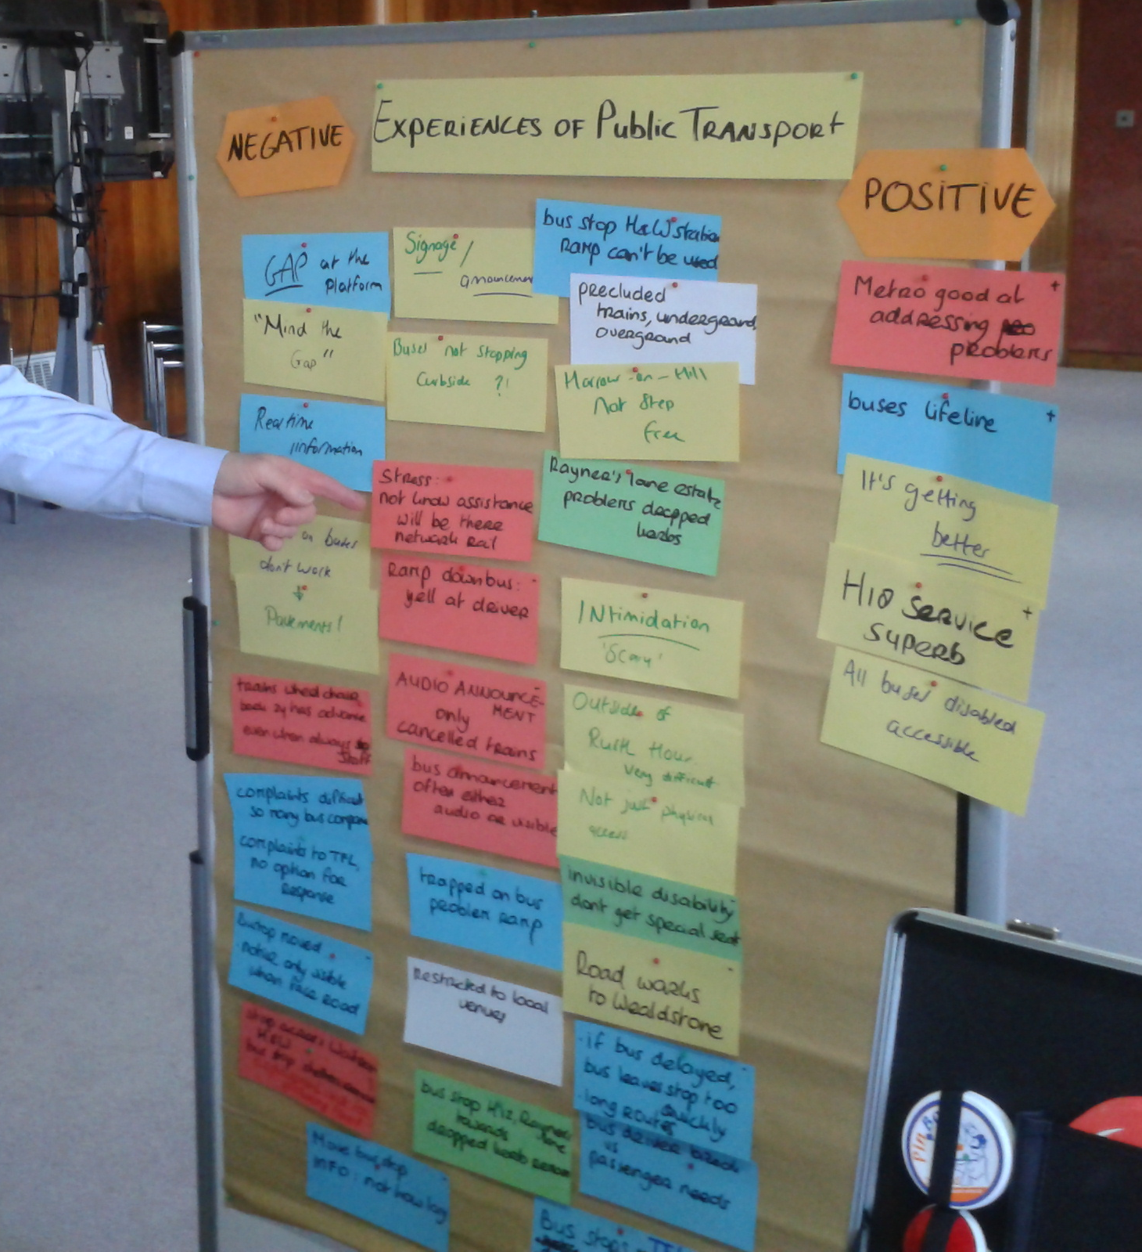
4.2 Unfortunately, other residents have indicated that it was difficult for them to travel long distances, use certain modes of transport or travel during rush hour, and some felt restricted to local venues or only one mode of transport. One resident, who uses public transport frequently, commented that she has never been able to travel alone - she is nearly thirty. She felt there were too many things that could go wrong which make travelling alone too risky. Members are concerned by the barriers that exist for access to services but also crucially to finding suitable work. Having to travel to work exceptionally early in the hope of having space on a bus for your wheelchair is difficult enough when your employer allows flexible working hours, let alone when employers can’t or won’t.
4.3 Unexpected circumstances only serve to increase these difficulties. One resident tells a story of when she was travelling with her father. At the station they wanted to get off, they couldn’t see the employee with the ramp, so her father left the train to try and find the employee. While he was off the train, the doors started closing and the train started to leave. This resident couldn’t have reached the open doors button herself to try to stop the train from leaving. If a fellow passenger hadn’t used the emergency stop, which meant the train stopped at that platform, she would have been stuck on that train by herself. There may not be another accessible station along the route and even if there was, employees at any given station or even on the train don’t know a person with a wheelchair is on that train and needs assistance.
4.4 Members were concerned that the two participants in the journeys through the borough indicated they both know several people with disabilities who don’t use public transport at all. The stress caused by using public transport prevents many of their friends from travelling. One participant in the seminar indicated that it can be intimidating to use public transport; another resident’s only suggestion to improve the accessibility of public transport in Harrow was to have good eyesight. These are incredibly unfortunate reminders of the barriers to accessible public transport that still exist.
4.5 The Council offers a volunteer based travel mentor scheme, the Harrow Travel Training and Buddying Project, that supports people who find public transport inaccessible in using public transport, where the training of the volunteers and their travel is funded by TfL. Members were pleased that a representative from Metroline bus suggested using this scheme for the bus company’s training to address awareness issues, and agreed that this should be included as a recommendation for other local bus companies.
Recommendation A
Local bus companies should be offered the opportunity to gain awareness of disabled passengers’ travel needs by participating in the Harrow Travel Training and Buddying Project (Harrow Council’s travel mentoring scheme) as part of bus driver induction training.
Pavements and footpaths
4.6 The Council does a routine cycle of inspections of the roads in the Borough which is the basis for a programme of repairs. It keeps a score of the number of defects in a road as well as a record of the Council’s ability to modify the defects. These records are used as a basis to determine which works have priority. If the Council is aware of where disabled residents live, this is taken into account in the assessment. Streets works in that area become a priority for the Council to resolve.
4.7 Participants in the review have identified difficulties created by uneven pavements. The paving between the town centre and Morrisons underneath the main road was shown to be a particularly significant example as the bricks are placed in a circle and the surface is uneven and textured. Several residents have mentioned they have difficulties moving across this area in their wheelchair or with their rollator. One resident even opts to use the bicycle lanes despite the associated risks.
4.8 A resident at the seminar indicated that the Rayners Lane estate has a lack of dropped kerbs. The dropped kerb near the H12 bus stop on one side of the road has even been removed, which makes the bus service significantly less accessible.
4.9 Shared spaces - where a single, level surface is shared by all vehicle and pedestrian users, such as for example on Exhibition Road in Kensington and Chelsea – are difficult for Visually Impaired People (VIP) to navigate due to the lack of demarcations between road and pavement that help keep a straight line and can prevent traffic accidents. Members are concerned by the potential risks of shared spaces and would encourage the Council to provide adequate demarcations between roads and pavements for VIP’s.
4.10 When road works, building works or gas works are taking place, the Council aims to provide adequate space and temporary ramps. It also liases with companies about prospective street works and provides letter drops to residents who live in the neighbourhood to make them aware that works will be happening.
4.11 Members have noticed that notifications about obstructions to roads aren’t always adequate. Parts of the pavement on Headstone Road and Junction Road are fenced off due to building work on Bradstowe House. The fencing blocks off a dropped kerb at that specific corner and the space left on the pavement at the corner is quite narrow, which risks someone in a wheelchair becoming stuck. Unfortunately, there were no notifications on the fencing that the dropped kerb at that corner had become unusable. Members feel it should be relatively easy to provide notifications at this and other sites in the borough with similar problems.
Recommendation B
Where road works are taking place and pavements have become impossible or extremely difficult for residents with mobility difficulties to use (including those in wheelchairs), the Council should provide clear signage ahead of the obstruction.

4.12 The Council is responsible for the provision of traffic signs in the borough. A resident with a visual impairment who uses a white cane mentioned how easy it is to miss the pole a sign is placed on and subsequently bump one’s head against the sign.
Recommendation C
Traffic signs should be installed so that they do not cause an obstruction to people with visual impairments. This could include being mounted on walls instead of pavements or the use of longer posts to ensure the sign itself is well above head height.

4.13 Members of the review group were informed that when designing any new infrastructure, one of the main aims of the Council is to reduce accidents. Members were pleased to hear that Harrow has either the second lowest or joint lowest number of road accidents in London. In the consultation the crossing between Stanmore Hill, Church Rd and The Broadway was mentioned as particularly dangerous for pedestrians. Currently, it isn’t obvious that the traffic lights aren’t programmed to accommodate pedestrians crossing. A resident suggested including a pedestrian phase in the traffic lights’ sequence. The Council is working with TfL to investigate the crossing including adjusting traffic signals in the area and monitoring the impact on traffic flow in the area to see if a pedestrian phase could be introduced in the traffic lights’ sequence of the crossing.
Recommendation D
The safety of the crossing between Stanmore Hill, Church Road and The Broadway should be investigated including the options of introducing a pedestrian phase in the traffic lights’ sequence or, if this is not possible, providing safety warnings that indicate the traffic lights’ sequence is not designed to safeguard pedestrians. The Council should make improvements where necessary.

4.14 Members were shown during one of the journeys how difficult it can be for Visually Impaired People to walk in a straight line. Members expressed their surprise at how challenging it can therefore be to cross wide, level crossings safely. The resident participating in the journey mentioned he sometimes ends up metres down the road by the time he has crossed. The example shown during a journey was crossing Wilson Gardens while walking from Vaughan Road to The Gardens in West Harrow. These situations could potentially be quite dangerous due to traffic.
Recommendation E
Future consideration should be given to include tactile paving and bumps across the full length of wide, long, level crossings to ensure these can be used as pathways by Visually Impaired People.

4.15 A specific difficulty raised by a resident with a Visual Impairment is that he can get lost quite easily. One resident explained that once he’s lost, it is difficult, if not impossible, to find his way again without help. He can’t call anyone for help because he’d be unable to describe his surroundings accurately enough. The current solution is to just wait for someone to walk past and ask for help, which can sometimes take 15 to 20 minutes. The resident indicated that the provision of talking GPS systems would be a great improvement.
Bus stops and buses
4.16 Harrow Council is going to great lengths making all bus stops in the borough accessible. In the borough there are more than 430 bus stops and 87% of them will be Disability Discrimination Act (DDA) compliant at the end of the financial year. The Council’s target is to make the bus stops in the borough compliant by 2015, which would be ahead of TfL’s target for London. This can include installing new accessible bus stops near existing stops that can’t be improved or moved. All TfL commissioned buses are required by TfL to be equipped with ramps and wheelchair spaces.
4.17 One participant at the seminar described buses as his lifeline and described the H18 bus service as superb. Other residents identified several issues with bus services, some specific to certain stops and bus routes, others more structural.
4.18 According to residents at the seminar, many bus stops are cluttered with fixed bins, lamp posts and signs. This means that even if the kerb has got the right height and the ramp works properly, there can be a lack of space on the kerb for passengers in wheelchairs to get on and off the bus. Members were informed that when the Council creates a new bus stop all aspects of accessibility including a clear pavement, are taken into account. For existing bus stops this is more difficult as for example there can be utility mains in the ground or private land can surround the stop.
4.19 During the seminar it was mentioned that often bus drivers will say that the kerb at certain bus stops isn’t suitable to use the ramp, so they’re unable to let passengers in wheelchairs off. It can be unclear to passengers which stops are accessible at any given time. TfL regularly monitors its transport services via the London Mystery Traveller Survey where older and disabled passengers monitor bus service independently while under cover. The monitor shows that 98% of wheelchair users are able to successfully board their first bus.
4.20 An elderly resident at the seminar commented that especially when a bus has been delayed, the bus tends to leave the bus stop very quickly. This makes it difficult to find a seat in time for passengers who are (a bit) unstable on their feet. There can be a tension between the needs of passengers and the schedule of the bus drivers, including heir schedule for changing buses and breaks. According to the London Mystery Traveller Survey older and disabled passengers are able get to a seat or grab hold in time 90% of the time. TfL will continue to work with bus operators on the 10% of bus drivers who currently do not comply with these basic safety considerations.
Recommendation F
The Council should encourage transport providers to regularly remind bus drivers of the necessity to provide sufficient time before leaving the bus stop for elderly passengers or passengers with mobility difficulties to find a seat.

4.21 Alongside these general difficulties to have fully accessible buses, issues specific to certain stops were also identified. One example is that the bus stop at Harrow and Wealdstone station on The Bridge (for the buses going into the town centre) isn’t accessible with the ramp. One resident has used it several times, and every time the ramp has broken because of the severe gradient between the pavement and the ramp.
4.22 Members were interested to find out whether bus drivers would be able to log issues with specific bus stops and feed these comments to the Council. Members have received comments from TfL’s Consultation Delivery Surface Planning team that it wouldn’t be practical for bus drivers to actively audit bus stops. Members do feel that even if bus drivers can’t audit stops, their expertise in using these stops means they should be able to feed comments about the accessibility of stops back to the Council.
Recommendation G
Bus drivers possess first-hand experience of the accessibility of specific bus stops and should be encouraged to report specific concerns. The Council should cooperate with bus companies to gain access to that information and consider it as part of its annual work programme for road works.

4.23 Residents have fed back that when using a bus while in a wheelchair, communication with the bus driver is extremely difficult. Asking the bus driver for assistance is difficult, if not impossible, while waiting on the pavement to enter the bus. Once inside the bus conversations with the driver are equally difficult due to the distance between the driver and the wheelchair space and the noise from traffic and other passengers. In the wheelchair space of the bus there is a special button which makes a distinct sound so the bus driver knows to extend the ramp at the next stop. A resident at the seminar commented that often the bus driver doesn’t hear this sound. Members noticed this happening several times during one of the journeys through the borough. Currently the only solution is for the passenger to shout loud enough for the driver to hear. Bus companies have informed members that this bell is used so regularly by other passengers it no longer serves to notify the drivers of the need for assistance. While members realise this situation can be difficult for drivers, they feel the presence of a passenger in a wheelchair on the bus should enable bus drivers to distinguish between legitimate and inadvertent use of the special bell.
4.24 Another difficulty experienced by wheelchair users when using buses, is that often the wheelchair space is taken up by buggies. Notices indicate that wheelchair users should have priority, but this isn’t always adhered to. Bus drivers can be reluctant to intervene and instruct passengers to fold down their buggies. There is very little space to manoeuvre in the bus itself, which makes it difficult for people to fold their buggy while the person in the wheelchair finds their space in the bus at the same time. Bus drivers could wait to extend the ramp until the buggy has been removed, but unfortunately this doesn’t always happen.
Trains, underground (tube) and overground
4.25 Trains have become more accessible for residents with visual impairments. Audible announcements in trains and tube about the stops to follow have been particularly helpful. However, only a limited number of stations in Harrow are accessible for people in wheelchairs. One participant of the seminar in use of a wheelchair does not use the train, underground or overground at all, and just relies on buses. During the seminar, the point was made that there should be more moveable ramps on trains and at stations. During the roundtable this point was re-emphasised when it was explained that a lack of ramps was a problem across London’s train and underground network.
Recommendation H
The Council should press partners to provide sufficient ramps at stations with step-free access to enable passengers to use all platforms.

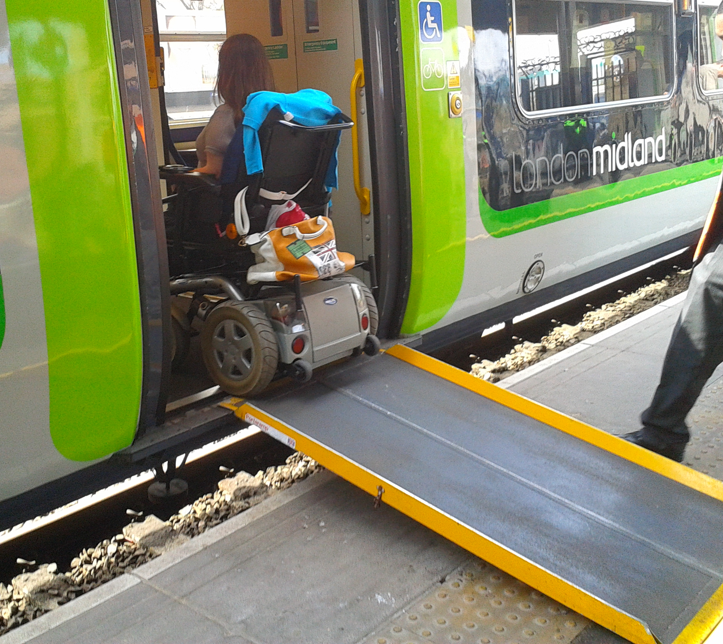
4.26 Even when a station is designated as wheelchair accessible, members agreed that there are still significant barriers to travelling. One significant restraint to travelling by train while in a wheelchair is that train stations require people in wheelchairs to book for assistance 24 hours in advance. This also happens at stations where there is always enough staff to assist. Often staff will let people on a train without booking in advance, but as they aren’t obliged to there is always a risk they won’t. Always knowing 24 hours in advance where one is going is severely restrictive compared to other passengers who have much more freedom in deciding their travel plans.
4.27 Furthermore, the options to travel late in the evening on trains are restricted for passengers in wheelchairs. For example the staff at Harrow and Wealdstone only work till 11.30pm, without whose assistance exiting the train becomes impossible in a wheelchair. Residents also commented on their reluctance to catch the last train in case the journey was disrupted or cancelled, there wouldn’t be any options to fall back on.
4.28 Members recognise that making travelling more flexible for people with mobility difficulties would probably involve a significant increase in staff as well as coordination, which in turn creates substantial costs. Members think it is regrettable that budget constraints may mean it’s not possible to provide passengers in wheelchairs with similar travel options to other passengers. Yet organisations such as Network Rail and TfL may still be able to identify in their travel information times when staff are always available at specific stations, and whether there are stations where assistance does not need to be booked in advance.
Recommendation I
The Council should consider encouraging travel providers such Transport for London and rail operators to provide travel information that includes the times staff are available at specific stations, and stations where assistance for train journeys does not need to be booked in advance should be highlighted.

4.29 Members have been informed by residents that using public transport with a disability means one is less flexible, which in turn means that unexpected changes can be distressing and create massive difficulties. One resident has provided the review group with a number of examples where she almost got stuck on trains if not for the assistance of nearby staff and fellow passengers. This resident, who uses a wheelchair, therefore possesses a wealth of knowledge about accessible stations, roads, bus stops and alternatives in Harrow and surrounding areas – all useful, if not necessary, for her to be able to use public transport. Since some passengers can’t always easily locate staff themselves to get assistance in such circumstances about travel options, the risk of a passenger becoming stuck on a train without an accessible option seems quite high. Members feel staff should be trained to always check whether passengers with disabilities are travelling on their services when these services become disrupted, diverted or terminated.
Recommendation J
The Council should encourage transport providers to include in their staff training full consideration of the travel needs of passengers with disabilities or other special requirements in those cases when journeys are disrupted, diverted or terminated. This specifically applies to train, underground (tube) and overground journeys.

Recommendation K
The Council should encourage transport providers to make it their staff’s responsibility to ensure that passengers with accessibility requirements receive appropriate assistance and advice on alternative accessible options when journeys get disrupted, diverted or terminated. This specifically applies to trains, underground (tube) and overground.
Stations
4.30 A limited number of stations in Harrow are step-free; namely Harrow & Wealdstone, Pinner, Headstone Lane and Hatch End. Not all of those stations provide step-free access from train to street, but many just from platform to street. Residents have indicated a number of station they feel should be made step-free: Harrow-on-the-Hill was frequently mentioned, but also Rayners Lane, Kenton and even Stanmore station, though officially labelled step-free, was mentioned a number of times.
4.31 Stanmore station is officially marked as step-free but due to the long, narrow and steep ramp and the exit from the car park to the road, in reality it is not. Members have visited Stanmore station and commented that the step-free route from the platforms to the bus stops was roughly 400 meters long and contains a very uneven and really steep slip road into the car park. In addition, the ramp between the car park and the station is also rather long and requires significant stamina for passengers in manual wheelchair to use alone. A significant concern is that until TfL acknowledges that Stanmore is not in fact step-free, it will be difficult to get help with funding or design. Members are pleased to hear that the Council continues to inform TfL of these difficulties and would suggest working together with the Royal National Orthopaedic Hospital as they would likely share concerns about the lack of step-free access at this station.
4.32 There can also be difficulties for passengers in exiting the trains at Stanmore Station. Only one of the three platforms at the station is level with the trains. This means passengers with mobility issues, especially those using a wheelchair, can arrive at a platform where they require assistance from staff with a ramp to exit the train. Without help from fellow passengers it may prove difficult to alert staff that this assistance is needed as the bells to notify staff are placed on the walls on the platform.
Recommendation L
That the Council should cooperate with the Royal National Orthopaedic Hospital to lobby TfL about the improvements needed to ensure Stanmore Station is functionally as well as technically step-free.

4.33 Positive news is that funicular lifts are being installed at Greenford station, which is a relatively cheap method of providing step free access. The suggestion was made to use them at more stations. These stations would require wide staircases.
4.34 Members were surprised to find that all the lifts on the concourse at Harrow & Wealdstone station have a small metal bar next to the lift doors making it more difficult for wheelchairs users to press the buttons for the lift. Following the round table discussion, London Underground Limited has indicated that, although it may take some time, they are working to remove these barriers.
4.35 At the seminar there was resounding agreement that Harrow-on-the-Hill station should be made step-free, as well as it being mentioned ten times in the consultation. In addition to the review, Harrow-on-the-Hill station has been consistently identified as an issue by (disabled) residents in consultations with the Council. As well as being the principal concern identified by London TravelWatch at their user engagement event in Harrow, November 2012.
4.36 One resident with a Visual Impairment commented that even though he is very familiar with Harrow-on-the-Hill bus station, it is still difficult for him to find the right bus. There are many buses, it is very noisy and there are many doors leading in and out of the station, all of which make the station difficult to navigate without help. In addition, members were informed that as the bus stops are on an island surrounded by a busy road, the safety of passengers at the bus station could also be improved.
4.37 Members were pleased to note all the ongoing work by Council officers to lobby TfL for step-free access at Harrow-on-the-Hill station. TfL has commissioned a new study into the costs of adapting Harrow-on-the-Hill station. The breakdown of costs for individual sections of the work is an important factor in determining future funding requirements for the Council. Rather than doing everything at once, one option could be to improve the station over time. Members suggested that the Council and TfL also look into getting sponsorship from private companies, in a similar way to the Emirates Airline cable car in East London.
Recommendation M
As part of the Council’s continued efforts to secure step-free access at Harrow-on-the-Hill station, consideration should be given to the option of finding private funding.

4.38 During our first journey through the borough, a resident using a wheelchair explained that when travelling from Harrow and Wealdstone station, the staff have recently only helped people in wheelchairs onto the fast trains where they used to assist them onto slow trains as well. A freedom pass, which enables older and disabled residents to use certain forms of public transport for free, does not cover journeys on fast trains but only on slow trains, which can create additional difficulties. One result has been that Carpenders Park station, which is accessible for people in a wheelchair via a manual boarding ramp, can’t be reached as the fast trains do not stop there. Members are concerned that even at a station with step-free access; passengers with mobility issues can’t use all the services available.
4.39 Members were shown during a journey how the hand rails provided at many stations make it much easier for Visually Impaired People to enter and exit stations. When the hand rails don’t run all along the wall but are interrupted, such as for instance at North Harrow station, it makes navigation more difficult. This should be a relatively cost-effective problem to solve.
Recommendation L
The Council should encourage partner organisations to provide hand rails at stations that run uninterrupted from street to platform for the benefit of Visually Impaired People.
Travel information
4.40 Members appreciated the continuous efforts made by TfL to provide comprehensive travel information, but still felt some improvements could be made. A positive comment received from a resident with a Visual Impairment is that currently the audible announcements in the tube are made slightly before the tube arrives at the next stop, which provides sufficient time to reach the door.
4.41 Residents raised several concerns about the travel information provided:
- London Transport provides good connections, but one respondent in the consultation did comment that particularly if one is not a frequent traveller, finding the appropriate accessible travel information can be difficult.
- Announcements at bus stops and train stations are often either visible or audible but not both.
- The digital displays at bus stops that indicate when the next bus is coming are only visible; announcements regarding delayed or cancelled trains are often only audible or the visible announcements have a severe delay.
- Announcements on the tube such as “Take care, the next station has a wide gap between platform and train”, are mostly only audible.
Recommendation O
Travel information should be both visible and audible where possible. Consideration should be given to expanding the information shown on digital displays for passengers with hearing difficulties as well as investigating the option of providing audible announcements at bus stops in the interest of passengers who are visually impaired.

Consultation with residents
4.42 Members are pleased that TfL has incorporated engagement with disability groups into its work, such as the ‘secret shopper’ monitor of bus services and extensive consultation with residents including disability groups while creating its transport policies.
4.43 Members were also pleased to note that the Council in turn ensures the LIP is widely consulted on with residents and disability groups. When any infrastructure or transport is designed by the Council, the Harrow Association of Disabled people (HAD) are asked for feedback. Other groups are also consulted: the Harrow Public Transport Users’ Association, Citizen’s Advice Bureau, Age concern and advisors to the Council’s Traffic and Road Safety Advisory Panel (TARSAP). In addition, the transport planning team liaise with housing officers, undertake site visits and consult occupational therapists. The transport planning team has also set up a separate group to consult residents with disabilities, which aims to meet twice a year.
4.44 TARSAP makes recommendations to the Council on:
- Traffic management;
- The management and control of parking both on and off-street;
- The operational aspects of public transport in the borough.
The members of the TARSAP are mainly Councillors from all parties, with three other advisors on the committee. There are a limited number of organisations that can nominate advisors to TARSAP, but HAD unfortunately is not included in that list.
Recommendation P
The Council’s inclusion of disabled residents in plans about transport in the borough is significant, but could be improved by changing the terms of reference of Traffic and Road Safety Advisory Panel (TARSAP) to enable a representative from a disability group such as the Harrow Association of Disabled people (HAD) to become an advisory member. This will enable continuous input from a representative on any of the Council’s proposals to change infrastructure.
5. CONCLUSION
5.1 Members were pleased to see the hard work that’s done by the Council and its partner organisations to improve accessibility to public transport. The majority of bus stops in the borough are accessible; travel information is continuously improved; transport providers and the Council continue to engage with passengers about their requirements.
5.2 Unfortunately, significant barriers to accessible transport still exist. Residents have consistently expressed difficulties they experience ranging from physical barriers to significant worries and concerns. Travelling quickly and easily for people with disabilities or elderly and frail residents is extremely difficult. When there are special circumstances, such as travel late at night or services being cancelled, problems become exacerbated.
5.3 To overcome all barriers to accessible public transport would be a Herculean task. Despite limited budgets and many competing priorities, members have identified some improvements that can be made. Though in many cases the Council can’t directly ensure transport becomes more accessible, members feel it can definitely use its relationships with partners to improve the accessibility of transport in the borough further.

6. RECOMMENDATIONS
A) Local bus companies should be offered the opportunity to gain awareness of disabled passengers’ travel needs by participating in the Harrow Travel Training and Buddying Project (Harrow Council’s travel mentoring scheme) as part of bus driver induction training.
B) Where road works are taking place and pavements have become impossible or extremely difficult for residents with mobility difficulties to use (including those in wheelchairs), the Council should provide clear signage ahead of the obstruction.
C) Traffic signs should be installed so that they do not cause an obstruction to people with visual impairments. This could include being mounted on walls instead of pavements or the use of longer posts to ensure the sign itself is well above head height.
D) The safety of the crossing between Stanmore Hill, Church Road and The Broadway should be investigated including the options of introducing a pedestrian phase in the traffic lights’ sequence or, if this is not possible, providing safety warnings that indicate the traffic lights’ sequence is not designed to safeguard pedestrians. The Council should make improvements where necessary.
E) Future consideration should be given to include tactile paving and bumps across the full length of wide, long, level crossings to ensure these can be used as pathways by Visually Impaired People.
F) The Council should encourage transport providers to regularly remind bus drivers of the necessity to provide sufficient time before leaving the bus stop for elderly passengers or passengers with mobility difficulties to find a seat.
G) Bus drivers possess first-hand experience of the accessibility of specific bus stops and should be encouraged to report specific concerns. The Council should cooperate with bus companies to gain access to that information and consider it as part of its annual work programme for road works.
H) The Council should press partners to provide sufficient ramps at stations with step-free access to enable passengers to use all platforms.
I) The Council should consider encouraging travel providers such Transport for London and rail operators to provide travel information that includes the times staff are available at specific stations, and stations where assistance for train journeys does not need to be booked in advance should be highlighted.
J) The Council should encourage transport providers to include in their staff training full consideration of the travel needs of passengers with disabilities or other special requirements particularly when journeys get disrupted, diverted or terminated. It should be the staff’s responsibility to ensure the passengers receive appropriate assistance and advice on alternative accessible options. This specifically applies to trains, underground (tube) and overground.
K) The Council should encourage transport providers to make it their staff’s responsibility to ensure that passengers with accessibility requirements receive appropriate assistance and advice on alternative accessible options when journeys get disrupted, diverted or terminated. This specifically applies to trains, underground (tube) and overground.
L) That the Council should cooperate with the Royal National Orthopaedic Hospital to lobby TfL about the improvements needed to ensure Stanmore Station is functionally as well as technically step-free.
M) As part of the Council’s continued efforts to secure step-free access at Harrow-on-the-Hill station, consideration should be given to the option of finding private funding.
N) The Council should encourage partner organisations to provide hand rails at stations that run uninterrupted from street to platform for the benefits of Visually Impaired People.
O) Travel information should be both visible and audible where possible – consideration should be given to expanding the information shown on digital displays for passengers with hearing difficulties as well as investigating the option of providing audible announcements at bus stops in the interest of passengers who are visually impaired.
P) The Council’s inclusion of disabled residents in plans about transport in the borough is significant, but could be improved by changing the terms of reference of Traffic and Road Safety Advisory Panel (TARSAP) to enable a representative from a disability group such as the Harrow Association of Disabled people (HAD) to become an advisory member. This will enable continuous input from a representative on any of the Council’s proposals to change infrastructure.
7. ACKNOWLEDGEMENTS
Councillors
Councillor Sue Anderson | London Borough of Harrow
Councillor Marilyn Ashton | London Borough of Harrow
Councillor Jerry Miles | London Borough of Harrow
Councillor John Nickolay | London Borough of Harrow
Councillor Stephen Wright | London Borough of Harrow
Tony Wood | Co-optee, chair Harrow Transport User’s Association
Council Officers
Peter Barron | Principal planning officer
David Eaglesham | Service manager Traffic and Highway network management
Ann Fine | Transport policy officer
Phil Greenwood | Head of major development projects
Hanif Islam | Senior Professional Transport Planning
Stephen Kelly | Divisional Director of Planning
Paul Newman | Team leader Traffic management
Matthew Patterson | Senior Professional – LDF team leader
Fern Silverio | Divisional director collections & benefits
Mohammed Ilyas | Policy Officer Equalities and Diversities
Paul Najsarek | Corporate Director Community, Health and Wellbeing
Simone van Elk | Scrutiny Officer
External witnesses
Tim Bellenger | Director Policy and Investigation, London Travel Watch
Gerry Devine | Chair of Trustees, Harrow Community Transport
Paul Giles | Performance Delivery Manager, London Sovereign
Colin Izzard | Service Delivery Manager, Metroline
Stuart McManus | management trainee, Metroline
Mohhammad Hashmi | LUL Deputy Station Manager Wembley Central
Scott Lester | Regional Borough Programme Manager, TfL

These goals were set out in the Mayor’s Transport Strategy of May 2010 on page 6 and 7 of the Executive Summary.

